Running environment:

python 3.12.4

GPU: L4: 24GB VRAM 30TFLOPS

InternVL2-8B:

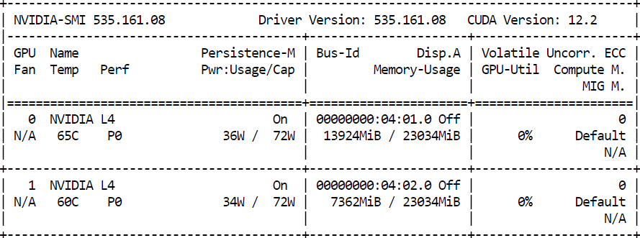

Image: meeting_chrohosome.jpg

Q: Is this relevant to a claim about attending academic conference?

Assistant: Yes, this document is relevant to a claim about attending an academic conference. It is an "Accepted Symposium" form for the Annual Meeting of the Human Genetics Society in Los Angeles, dated 26-31 May 1985. The form includes details about the symposium, including the title, session, and speakers, as well as contact information for the organizer and the meeting's office. This information would be pertinent to someone who attended the conference and needed to verify their participation.

Time: 21.23s

Q: list all the speakers

Assistant: The speakers listed in the text are:

1. Dr. William J. Schull

2. Dr. Jorge L. Yunis

3. Dr. Sheldon Wolff

4. Dr. Patricia Jacobs

5. Dr. Raymond White

6. Dr. Michael A. Bender

Time: 13.18s

Image: eg-petrol.jpg

--- model inference time 1: 14.11971926689148 seconds ---

User: <image>

Is this relevant to a claim about car expense?

Assistant: Yes, this receipt is relevant to a claim about car expenses. It includes details of a fuel purchase, which is a common expense associated with car usage. The receipt shows the amount spent on fuel, the type of fuel, and the total cost, which can be used to substantiate car-related expenses in a claim.

--- model inference time 2: 20.32930612564087 seconds ---

User: read the text and return information in JSON format. I need company name, address, phone number, date, ABN, and total amount

Assistant: ```json

{

"company_name": "EG Fuelco (Australia) Limited",

"address": "4 Luxton Street, Belconnen, PH 02 8039 387",

"phone_number": "02 8039 387",

"date": "02/06/24 09:09",

"ABN": "ABN 3962346465",

"total_amount": "$88.06"

}

Image: stout.png

--- model inference time: 23.321430683135986 seconds ---

User: read the text and return information in JSON format. I need company name, address, phone number, date, item name, number of items, item price, and total amount?

Assistant: ```json

{

"company_name": "Stout Industries, Inc.",

"address": "6425 W. Florissant Ave., St. Louis, MO 63136",

"phone_number": "(314) 385-2280",

"date": "October 16, 1987",

"item_name": "Harley Davidson Metal Plaque",

"number_of_items": 500,

"item_price": 9.18,

"total_amount": 460.00

}

Image: Receipt_2024-05-25_070641.jpg (double receipts)

--- model inference time: 126.58670735359192 seconds ---

User: describe this image

Assistant: This image shows two separate tax invoices from different stores.

1. **Left Invoice (Target)**

- Store: Target

- Website: target.com.au

- Location: Belconnen

- Date: 04/05/24

- Time: 01:11 PM

- Items:

- 6757044 Impulse: 4.00

- Otv 2 2.00

- 6867494 STAR GIFT BA: 10.50

- 6867553 BLUE GIFT BA: 2.25

- Total: 16.75

- Payment Method: EFTPOS

- Payment Details:

- Card Type: Mastercard

- Card Number: [Redacted]

- Expiry Date: [Redacted]

- Purchase Amount: 16.75

- Approval Number: [Redacted]

- No PIN or Signature Required

- EFTPOS Tender: 16.75

- GST Included in Total: 1.52

- Total: 18.27

- Flybuys Card: 6827

- Additional Information: Target has a 60-day return policy. For more information, visit [www.target.com.au](https://www.target.com.au/).

2. **Right Invoice (Bunnings Warehouse)**

- Store: Bunnings Warehouse

- Location: Canberra Airport

- Date: Fri 19/01/2024

- Time: 02:57:31 PM

- Items:

- 318010 Gas Exchange: $31.50

- 8.5KG Exchange Only: $32.98

- 12M 715167: $16.49

- 931720182016 Spade Plant Brass: $13.98

- 150mm HSS Spade Brass: $21.60

- 2 x 10.90

- 9313605625 Plant-Petunia: $7.99

- 180mm White: $5.98

- 125mm Guineas Impatiens: $5.98

- 3314400300 Geranium: $5.98

- 125mm Colourbloom Mix: $5.98

- 125mm Squatt Assorted: $4.98

- 0 x 2.49

- 0 x 2.00

- Subtotal: $127.19

- GST Included in Total: $11.56

- Total: $127.19

- Flybuys Card: 6827

- Additional Information: Bunnings Warehouse offers a 60-day return policy. For more information, visit [www.bunnings.com.au](https://www.bunnings.com.au/).

Both invoices include a note about the Flybuys Card, which offers 5x Flybuys in-store, express click and collect, free online delivery, and more.

InternVL2_8B_AWQ: by default cache_max_entry_count=0.8

<https://lmdeploy.readthedocs.io/en/latest/api/pipeline.html#lmdeploy.TurbomindEngineConfig>

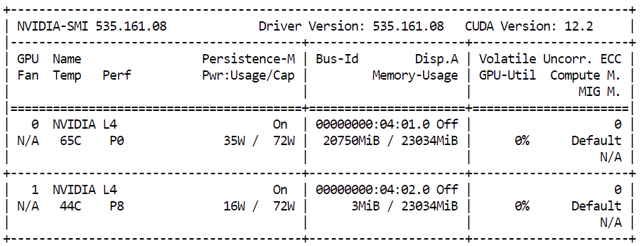

When cache_max_entry_count=0.4

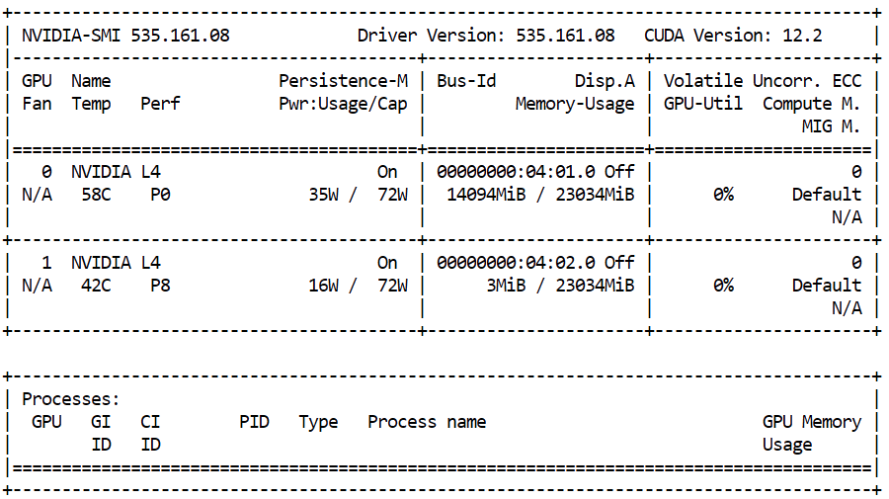

Image: conference

User: Is this relevant to a claim about attending academic conference?

Assistant: Yes, this document is relevant to a claim about attending an academic conference. It is an "Accepted Symposium" form for the Annual Meeting of the American Association of Autoimmunodiseases (AAAS) in Los Angeles, dated May 26-31, 1985. The form includes details about the symposium's title, speakers, and their affiliations, which would be pertinent to a claim about attending an academic conference.

Time: 3.28s

User: list all the speakers

Assistant: The speakers listed in the text are:

1. Dr. William J. Schull

2. Dr. Jorge J. Yunis

3. Dr. Sheldon Wolff

4. Dr. Patricia Jacobs

5. Dr. Raymond White

6. Dr. Michael A. Bender

Time: 2.68s

--- model inference time: 10.969998121261597 seconds ---

User: <image>

describe this image

Assistant: The image is a scanned receipt from Target, showing a tax invoice for a purchase made at Bunnings Warehouse. The receipt is dated April 15, 2024, and includes the following details:

**Store Information:**-

Target: target.com.au-

Belconnen-

Address: 02 6256 4000, ABN 75 004 250 944-

Tax Invoice: 04/15/24 01:11PM

**Bunnings Warehouse:**-

Canberra Airport-

Address: ABN 26 008 672 179, Phone: 02 6239 3300-

Date: Fri 19/01/2024 02:57:31 PM-

Nursery Hut R19

**Items Purchased:**

1. **Purple Impulse:** $4.00

2. **Star Gift Bag:** $10.50

3. **Blue Gift Bag:** $2.25

4. **Gas Exchange:** $31.50

5. **8.5KG Exchange Only:** $32.98

6. **12M Grapery Brass:** $13.98

7. **12M BSP Grip Lock:** $21.60

8. **9.5KG Exchange Only:** $10.90

9. **Mastercard Purchase:** $16.49

10. **Bench-New:** $7.99

11. **125mm Grp-New:** $5.98

12. **125mm Colourbloom Mix:** $5.98

13. **125mm Squatt Assorted:** $4.98

14. **0Z Potted Colour:** $2.49

15. **105mm Assorted:** $2.00

**Total Purchase Amount:** $127.19

**Payment Method:**-

Flybuys Card: $127.19

**Notes:**-

Target has a 60-day return policy.-

OnePass Membership benefits include 5x Flybuys in-store, express click and collect, free online delivery, etc.-

Instructions to visit [www.target.com.au/onepass](https://www.target.com.au/onepass) for more information.-

Instructions to keep the tax invoice/receipt as proof of purchase.

**Barcode and Receipt Number:** 15123 02840 06260 20240 50413 11526

Image: stout.png

--- model inference time: 3.8173835277557373 seconds ---

User: <image>

read the text and return information in JSON format. I need company name, address, phone number, date, item name, number of items, item price, and total amount?

Assistant:

json

{

"company_name": "Stout Industries, Inc.",

"address": "6425 W. Florissant Ave., St. Louis, MO 63136",

"phone_number": "(314) 385-2280",

"date": "October 16, 1987",

"item_name": "Harley Davidson Metal Plaque",

"number_of_items": 500,

"item_price": 9.18,

"total_amount": 4605.00

}

Image: petrol

--- model inference time 1: 3.835670232772827 seconds ---

User: <image>

Is this relevant to a claim about car expense?

Response: Based on the image, this document appears to be a tax invoice for a fuel voucher purchased from EG Fuelcard (Australia) Limited. While it does detail the purchase of fuel, it does not directly relate to a claim about car expenses. Instead, it is a receipt for the purchase of fuel vouchers.

If this document is used as part of a claim for car expenses, it would likely be used to show that the necessary fuel has been purchased, but the specific details about the car (such as make, model, and usage) are not provided in this document.

In summary, while the document is related to car expenses through the purchase of fuel, it does not contain information about the car itself or the nature of the expenses incurred.

--- model inference time 2: 2.182075262069702 seconds ---

User: <image>

read the text and return information in JSON format. I need company name, address, phone number, date, ABN, and total amount

Assistant: json

{

"company_name": "EG Fuelco (Australia) Limited",

"address": "4 Luxton Street",

"phone_number": "02 8073 3987",

"date": "02/06/24",

"ABN": "3962346465",

"total_amount": "$88.06"

}

40B-AWQ:

